|  |  |  |  |  |  |  |  |  |
| --- | --- | --- | --- | --- | --- | --- | --- | --- |
| |  | | --- | | Yunteng VCT-668 tripod | |  |  |  |  |  |  | | --- | --- | --- | --- | |  |  |  |  | |  | **Specifications:**  **Weight:** 1.3kg  **Maximum height:** 152 cm  **Minimum height:** 46 cm.  **Load bearing:** 3KG  **Price: 28$** |

**Overview:**

**Yunteng VCT-668 has a flexible design, easy to adjust**

The Yunteng VCT-668 tripod delivers beautiful photos without having to spend too much effort to calibrate the camera. All thanks to the integration of a water drop level scale and a flexible design that easily rotates in many directions.

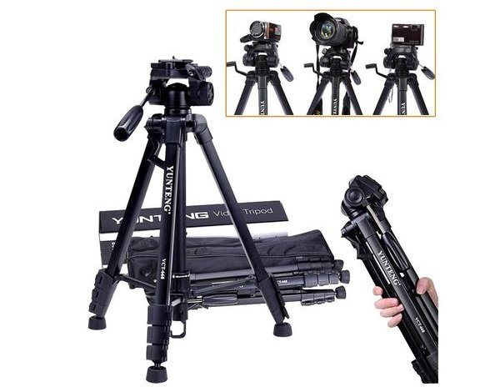

**Yunteng VCT-668 is gentle and sturdy**

With a weight of only 1.3 kg, this tripod is very light, providing a comfortable feeling when moving. The metal legs are also painted with an anti-oxidation layer, creating durability for the product. The minimum length is only 46 cm, helping it always accompany you on picnics and travel.